

Medium Level Programs (21-40)

Date – 13/03/2026

Name: M. Sahasra
Reg. No.: 192425317
Course Code: CSA0919
Course Name: Programming in Java for Spring Framework
Faculty Name: Dr. Magesh Kumar

21. Prime Number using Runnable Thread

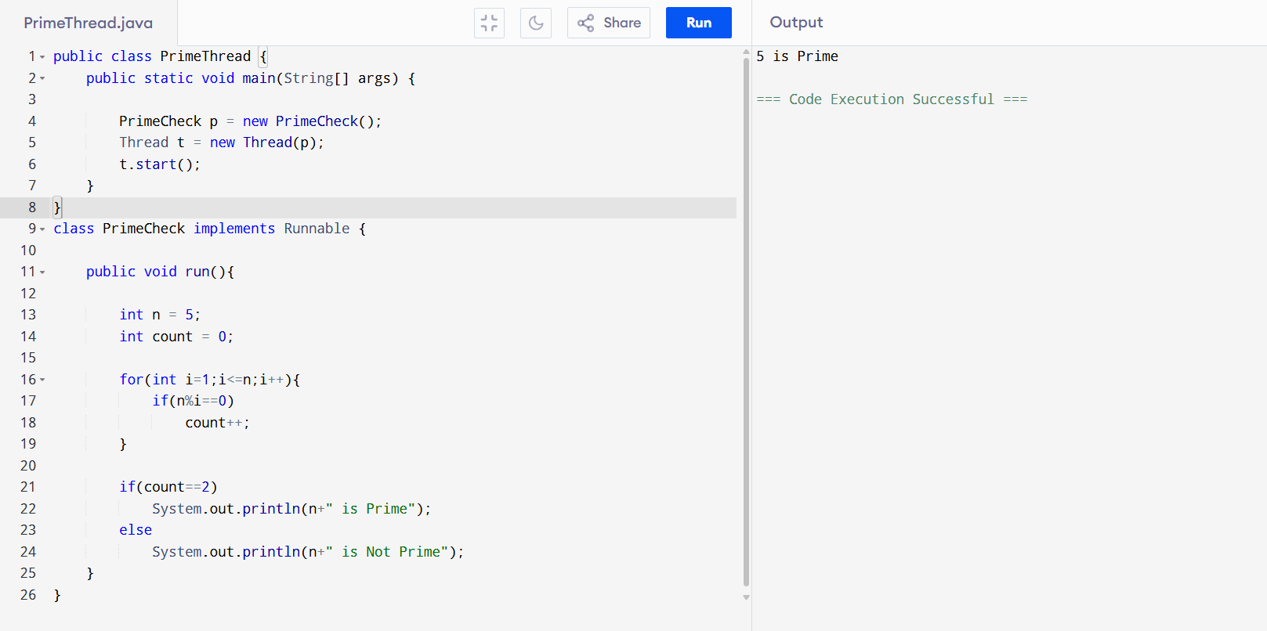

22. Multi-Catch Exception Handling
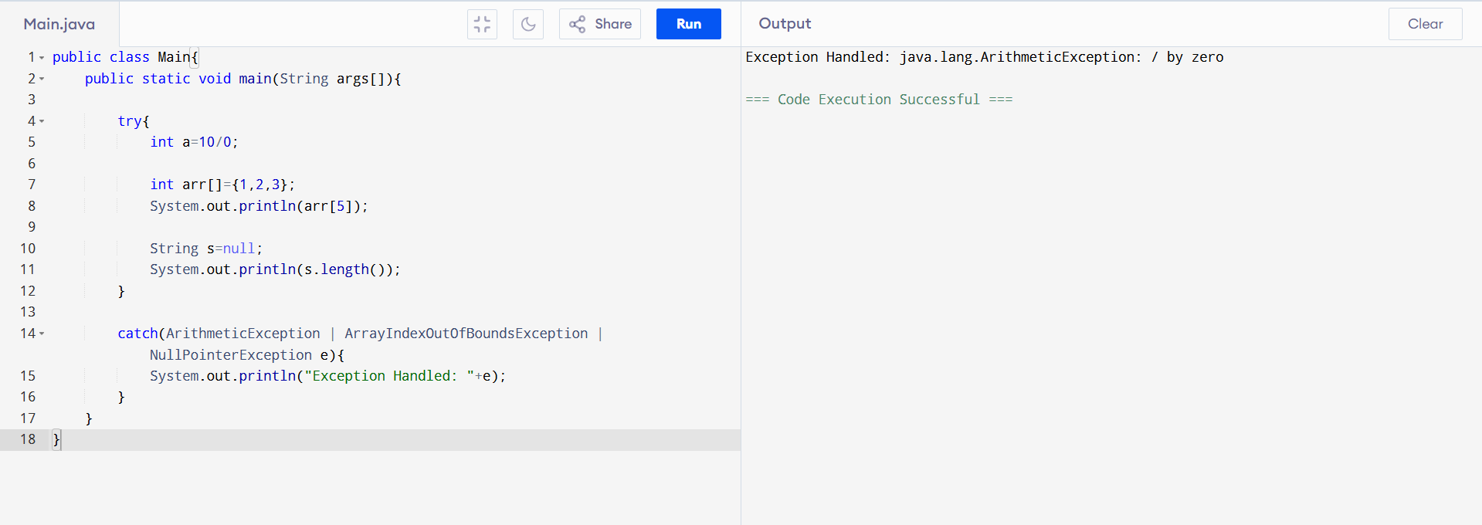

23. FileWriter and FileReader

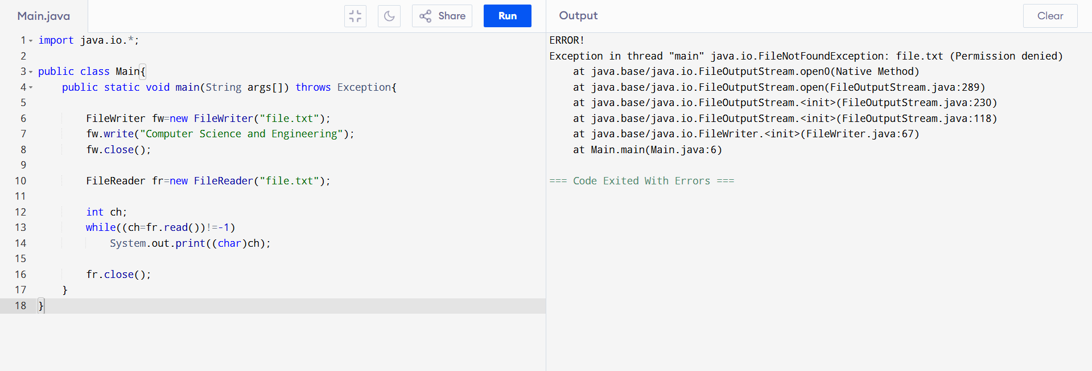

24. Volume of Box (Default Constructor)

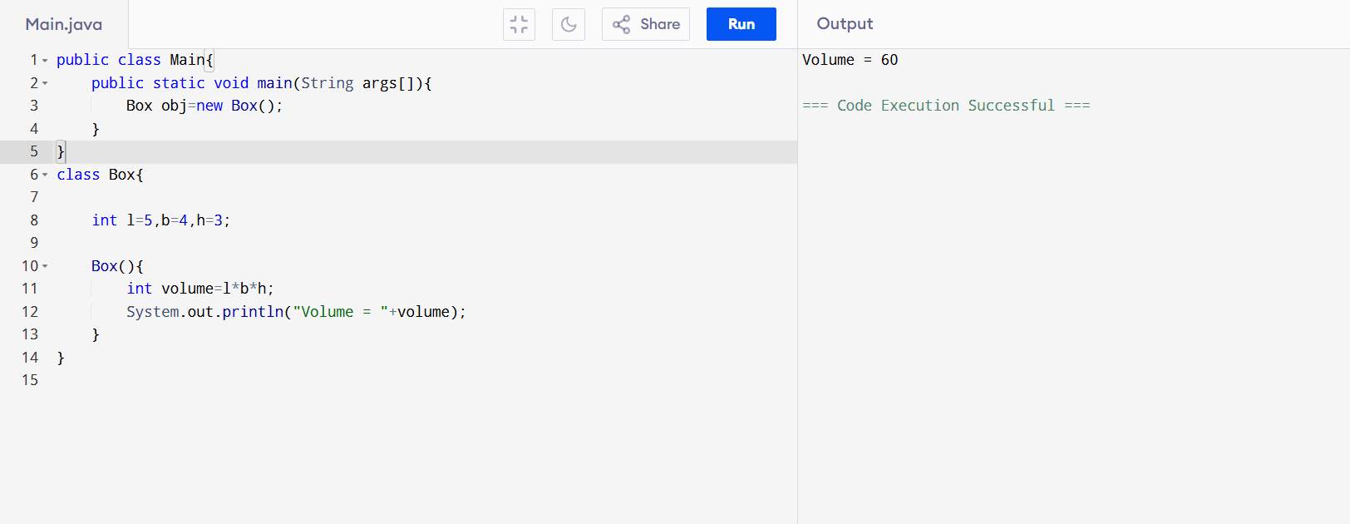
25. String Operations
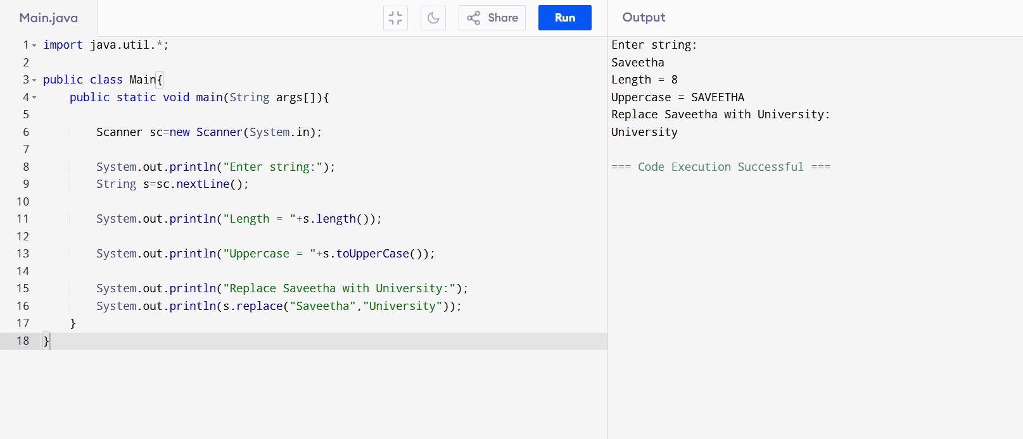
26. HashTable Bank Records
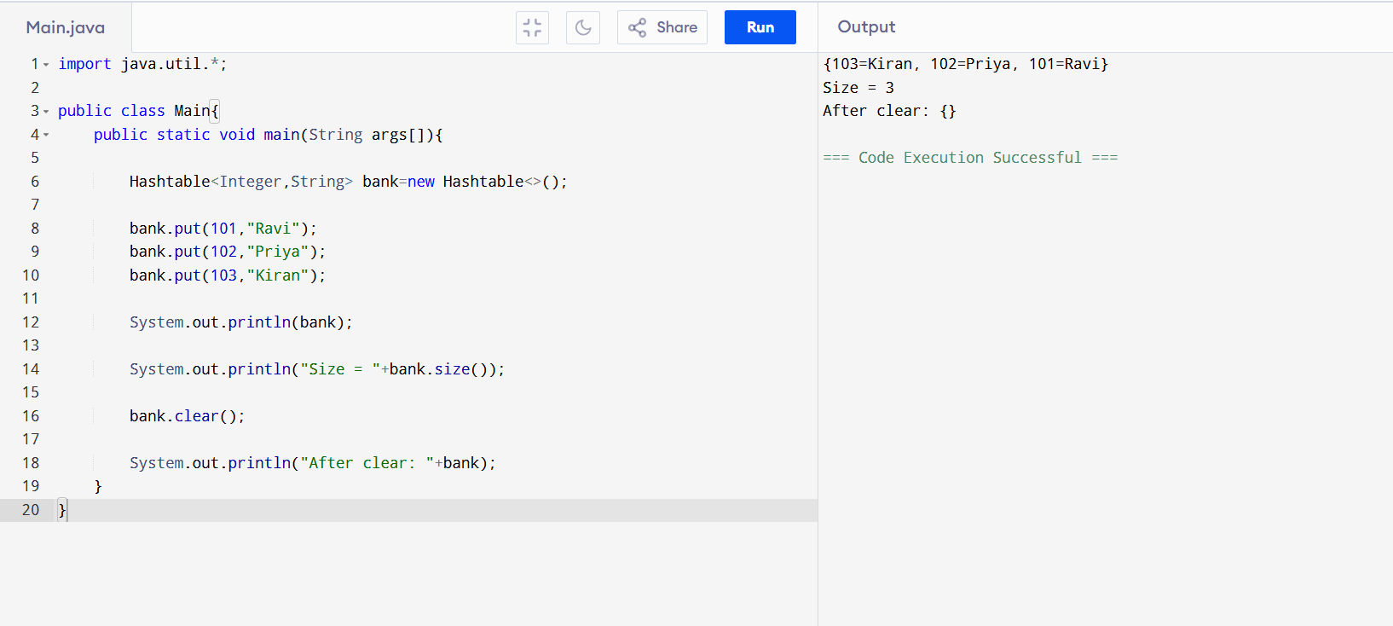
27. Employee Map Operations
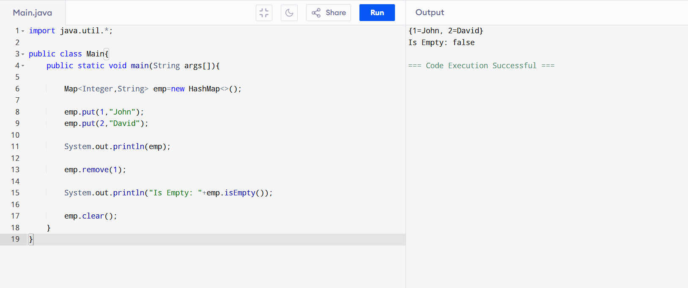
28. Generic Sorting Class
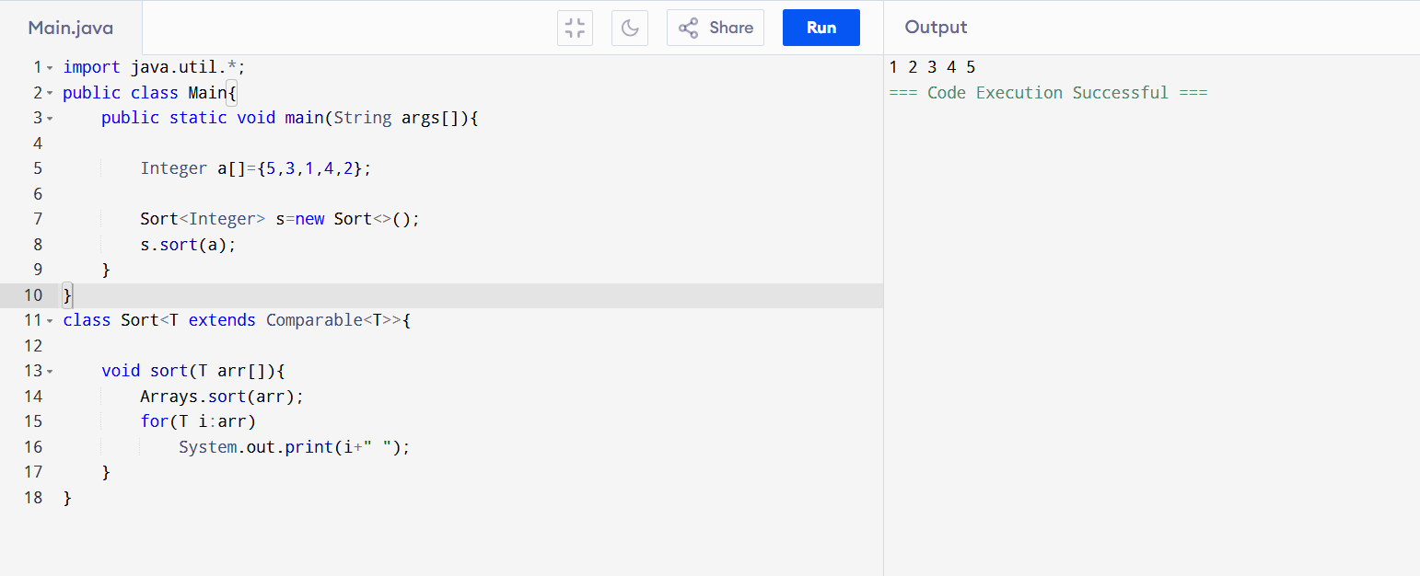
29. ListIterator Reverse Print
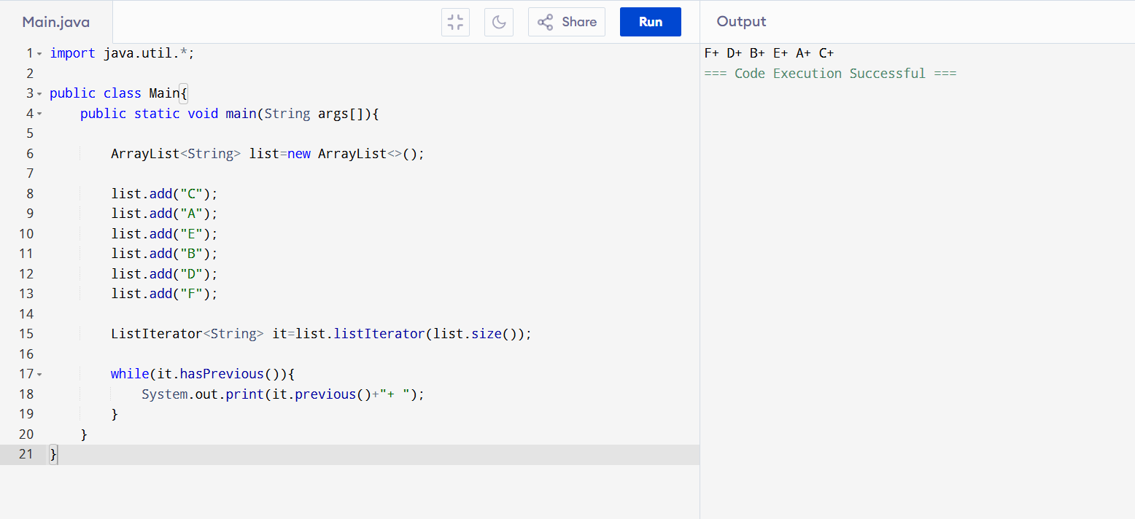
30. Arithmetic Exception (Divide by Zero)
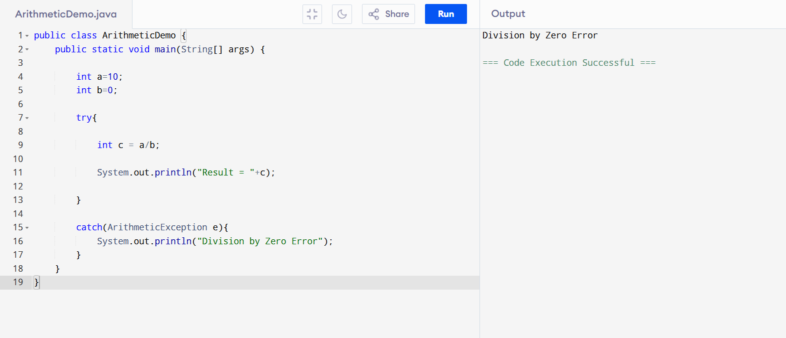
31. Three Threads Natural Numbers
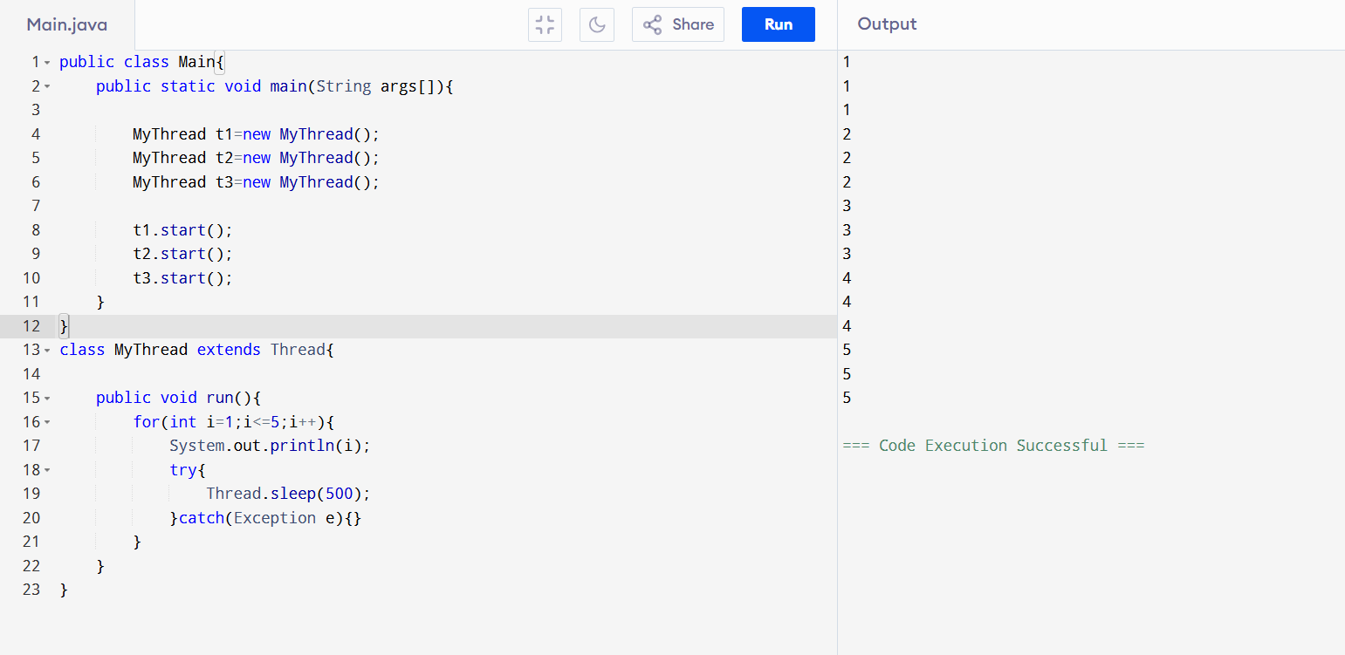
32. Find Missing Number
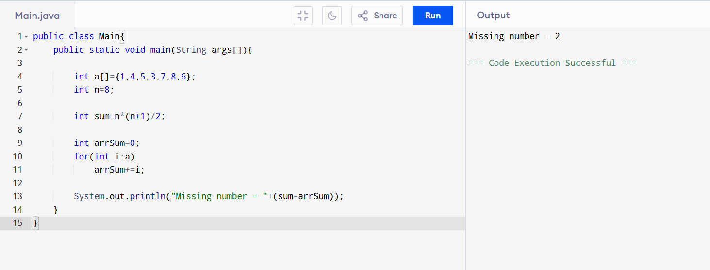
33. Parent and Child Class
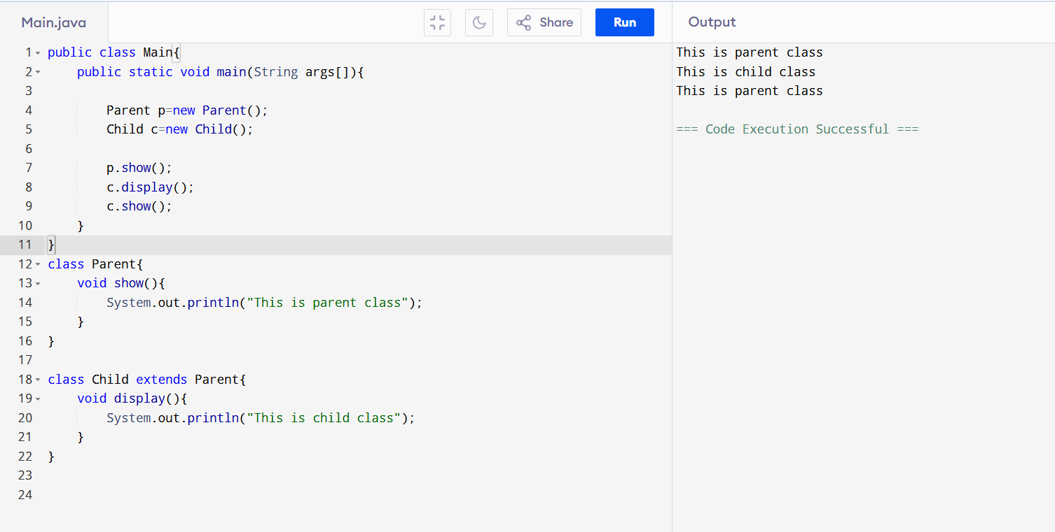
34. Student Constructor
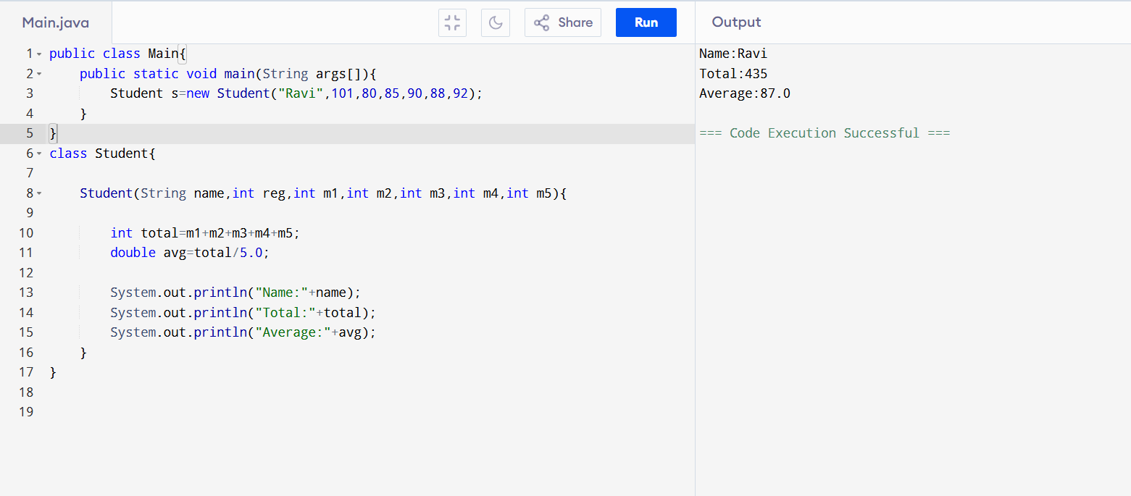

35. Count Words Characters Lines (File)
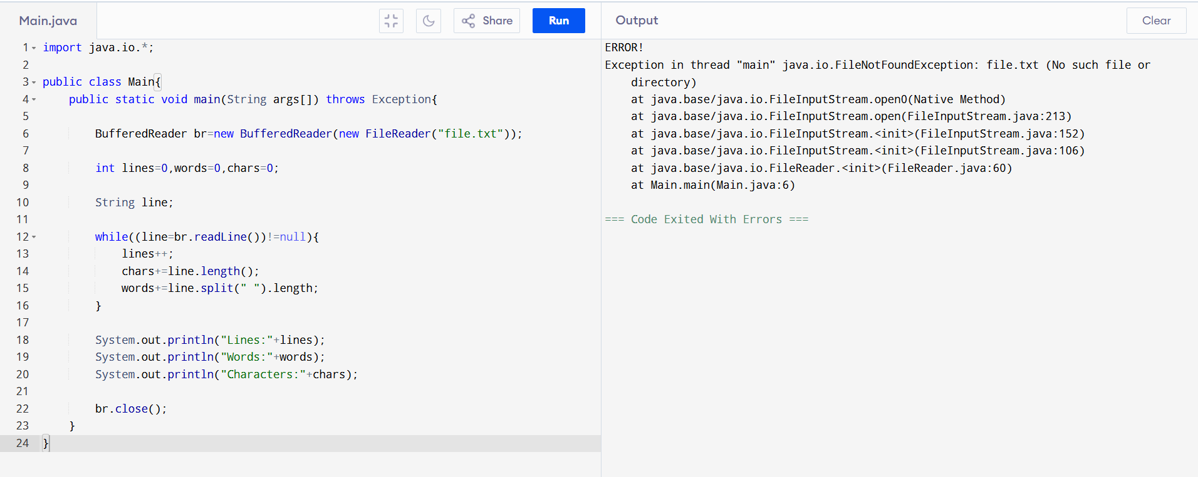

36. Multiply Two Numbers (String)
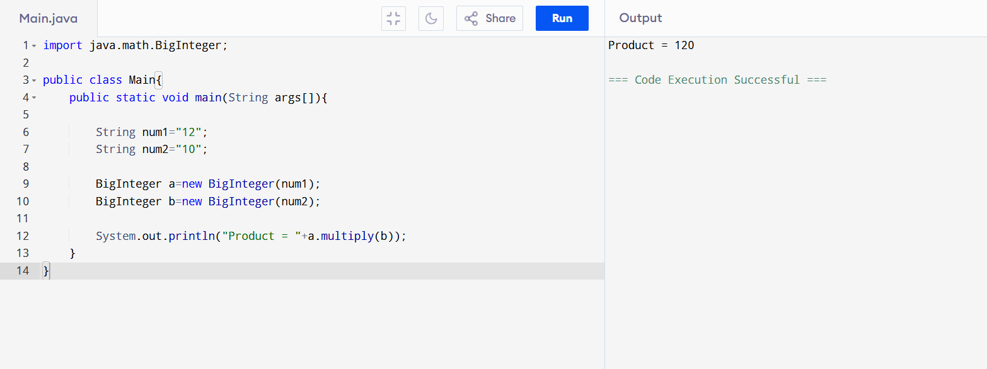
37. Power Function
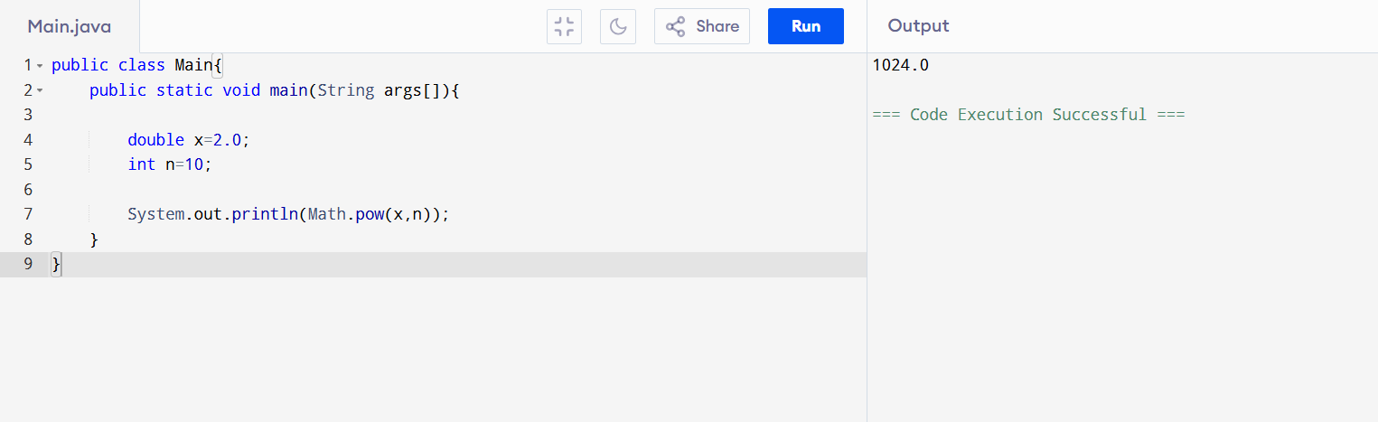
38. Maximum Subarray Sum
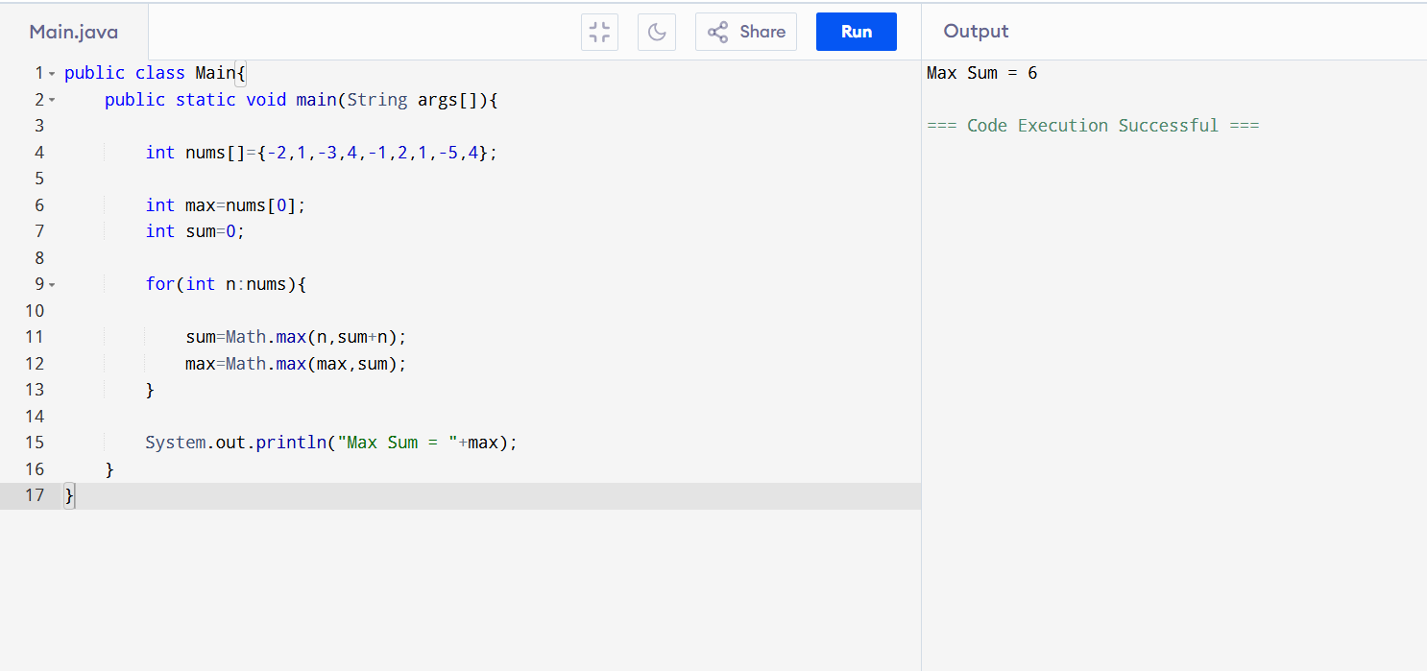
39. Exam Room Seating (Simplified)
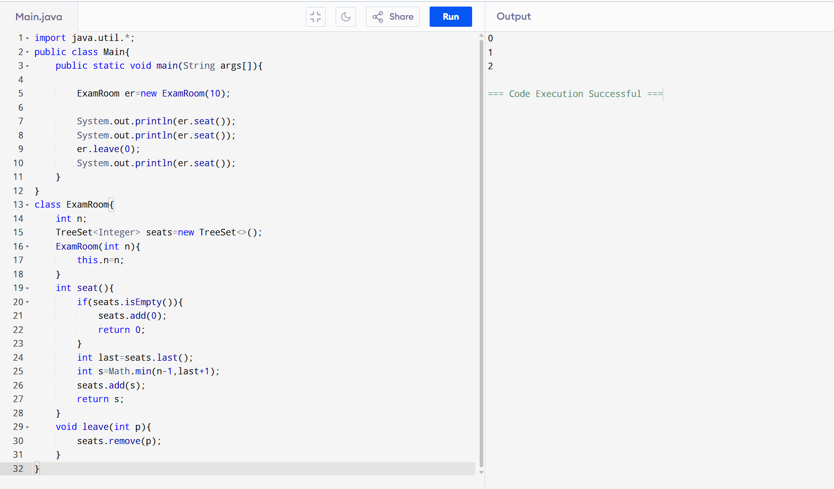
40. Letter Tile Possibilities
